**ScreenShots**

***Login Page on starting the Program***

Username: admin

Password: admin

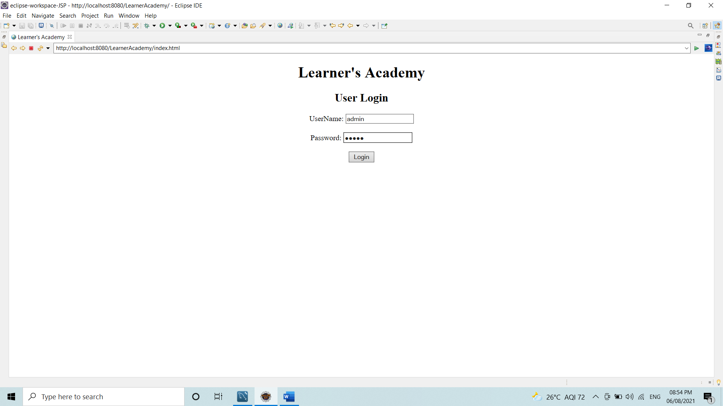

If the credentials gone wrong:

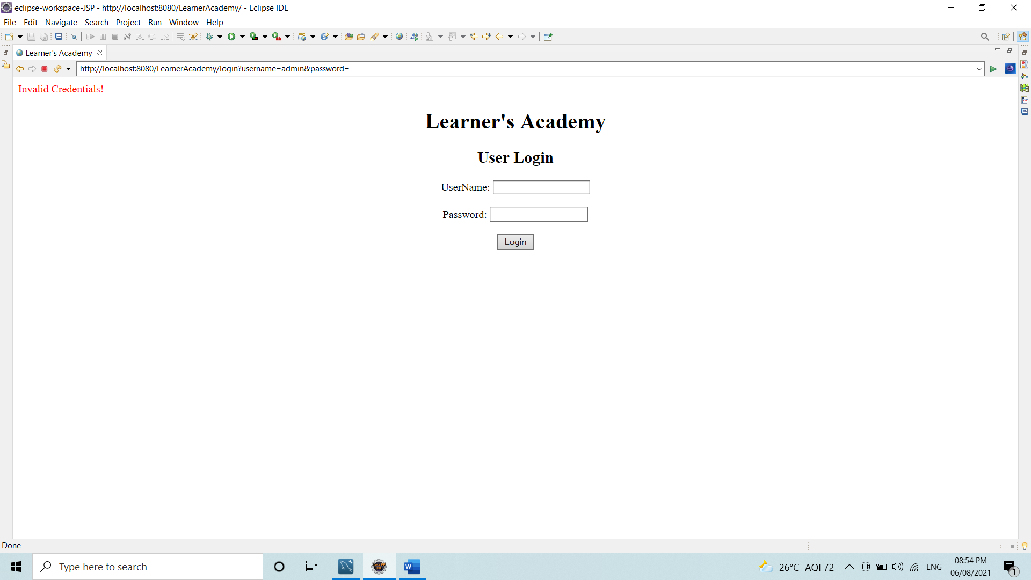

After Login with correct credentials:

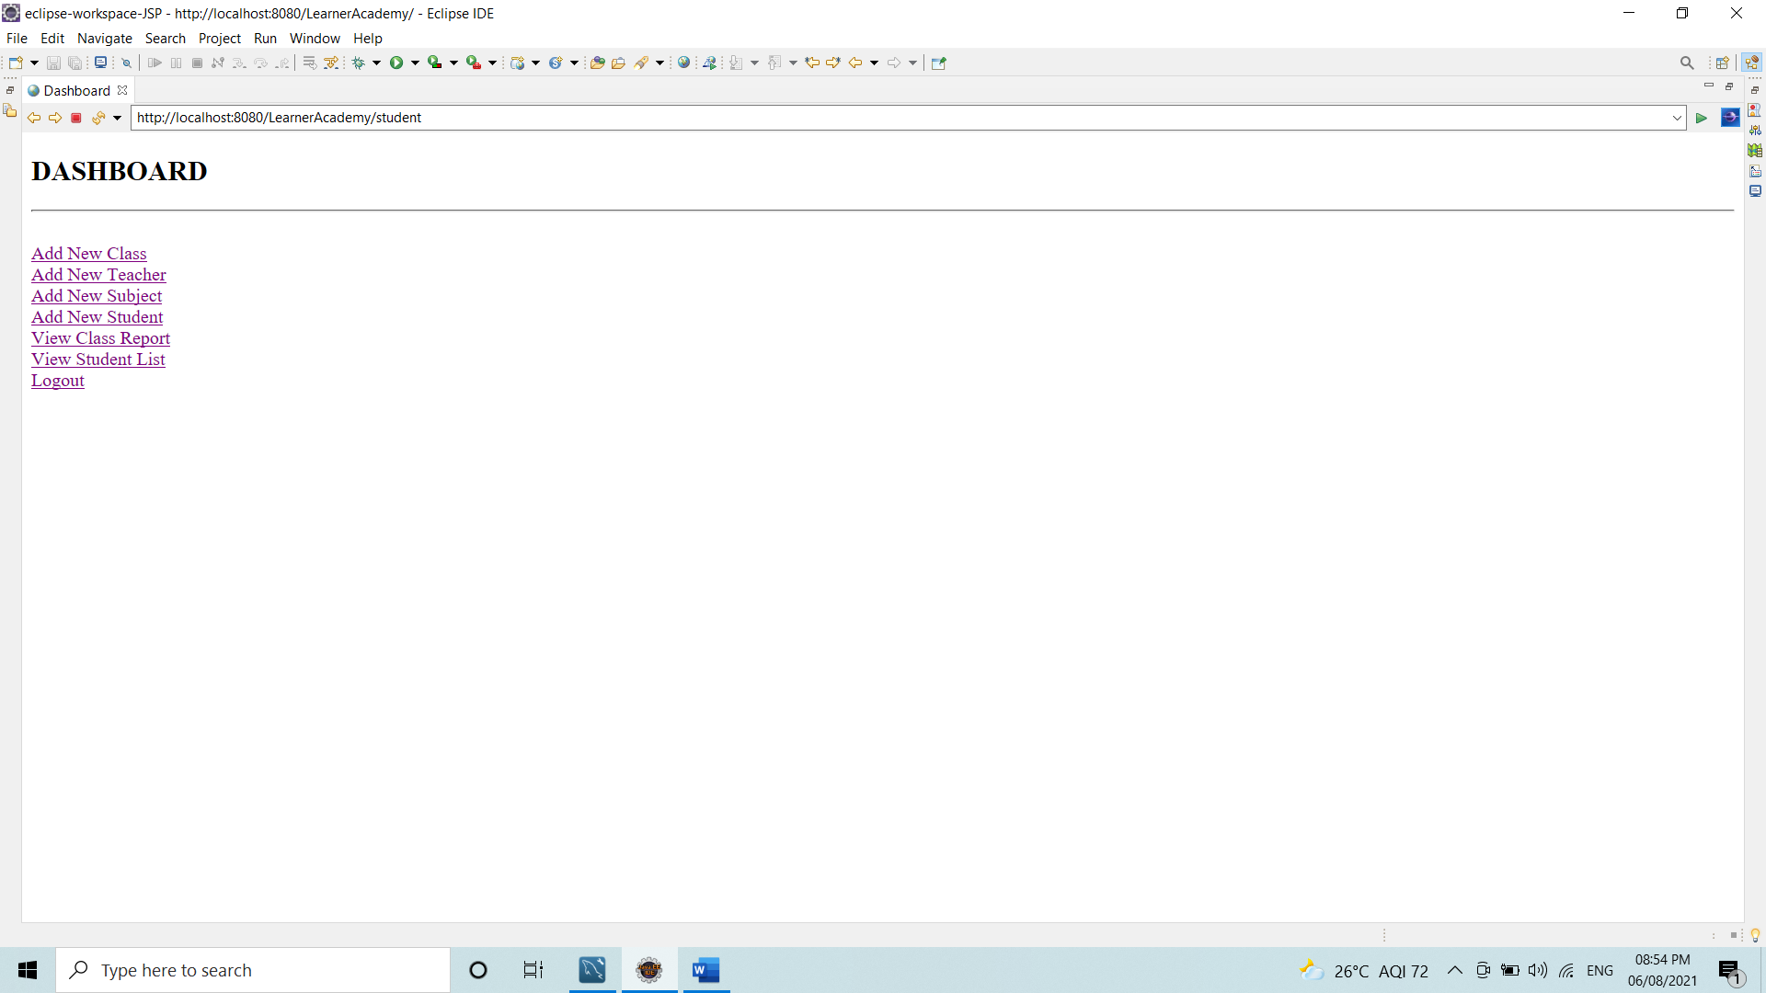

After Selecting Add New Class

It only Ask for Name of the class.

Suppose I want to register my new Class A

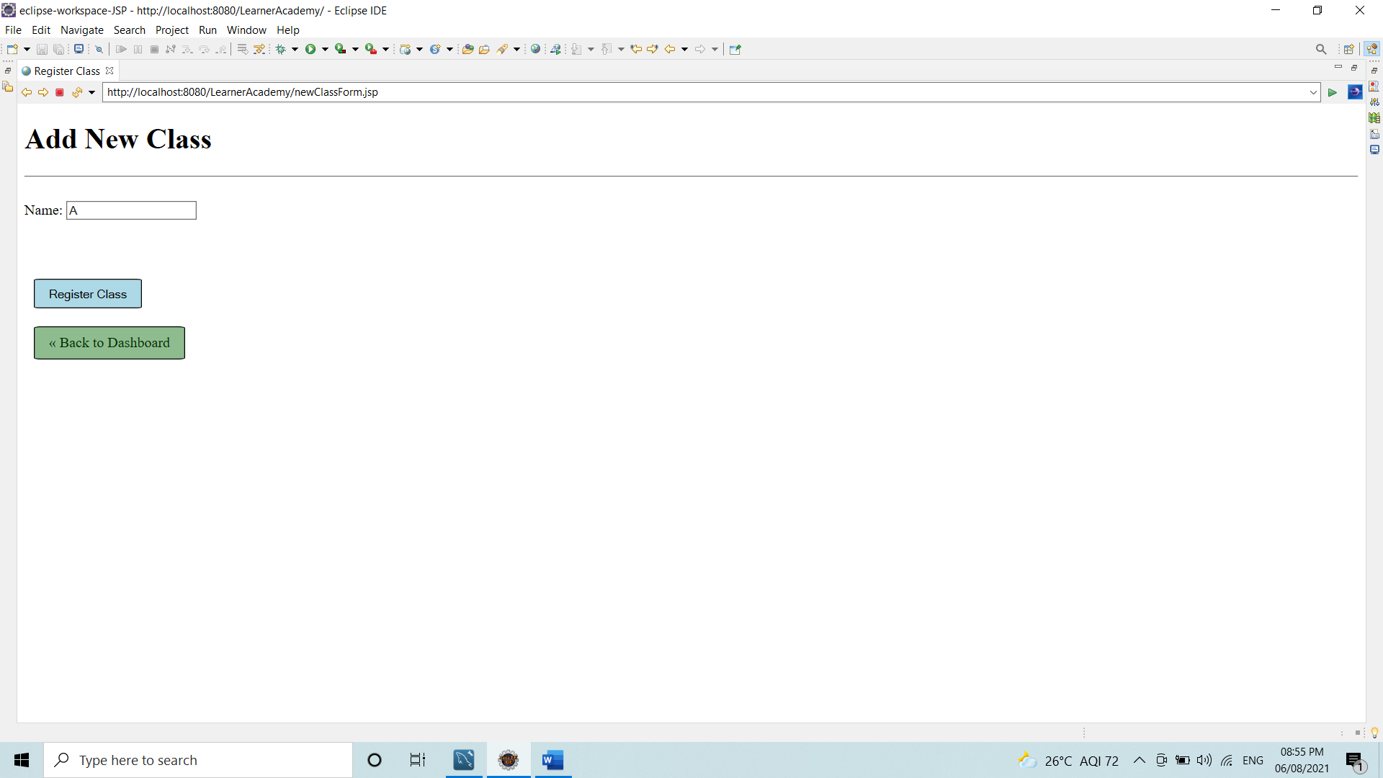

After Clicking on register class ,it add the Class A to database. If the class with same name is present it will not add the class.

If any error occurs:

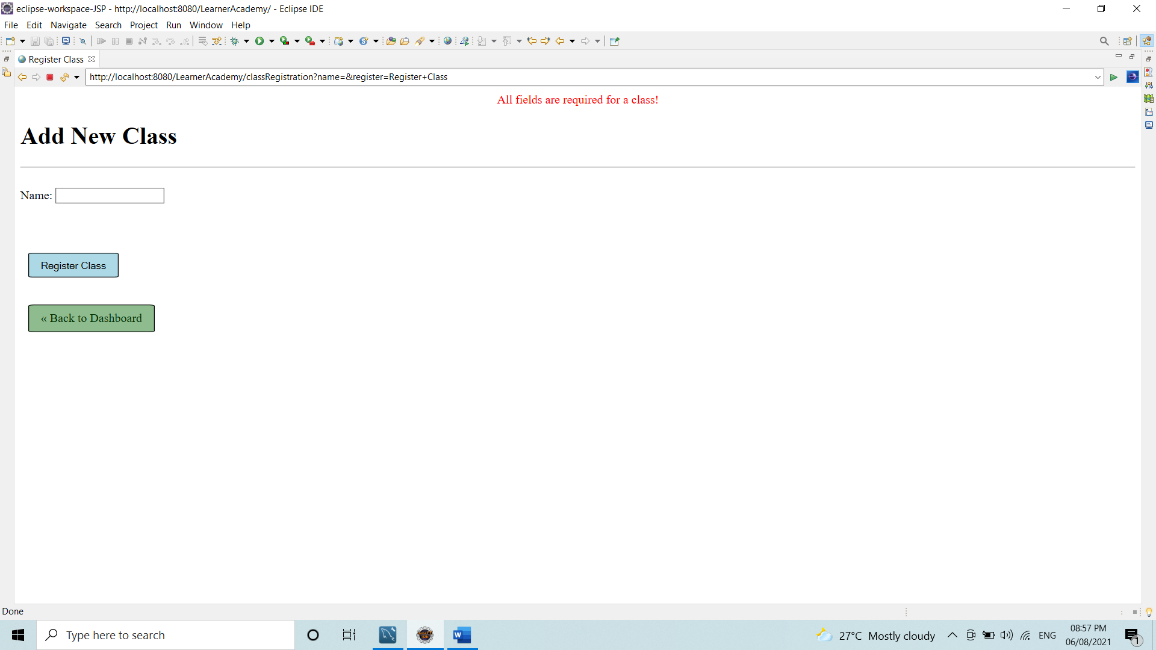

After Selecting Add New Teacher

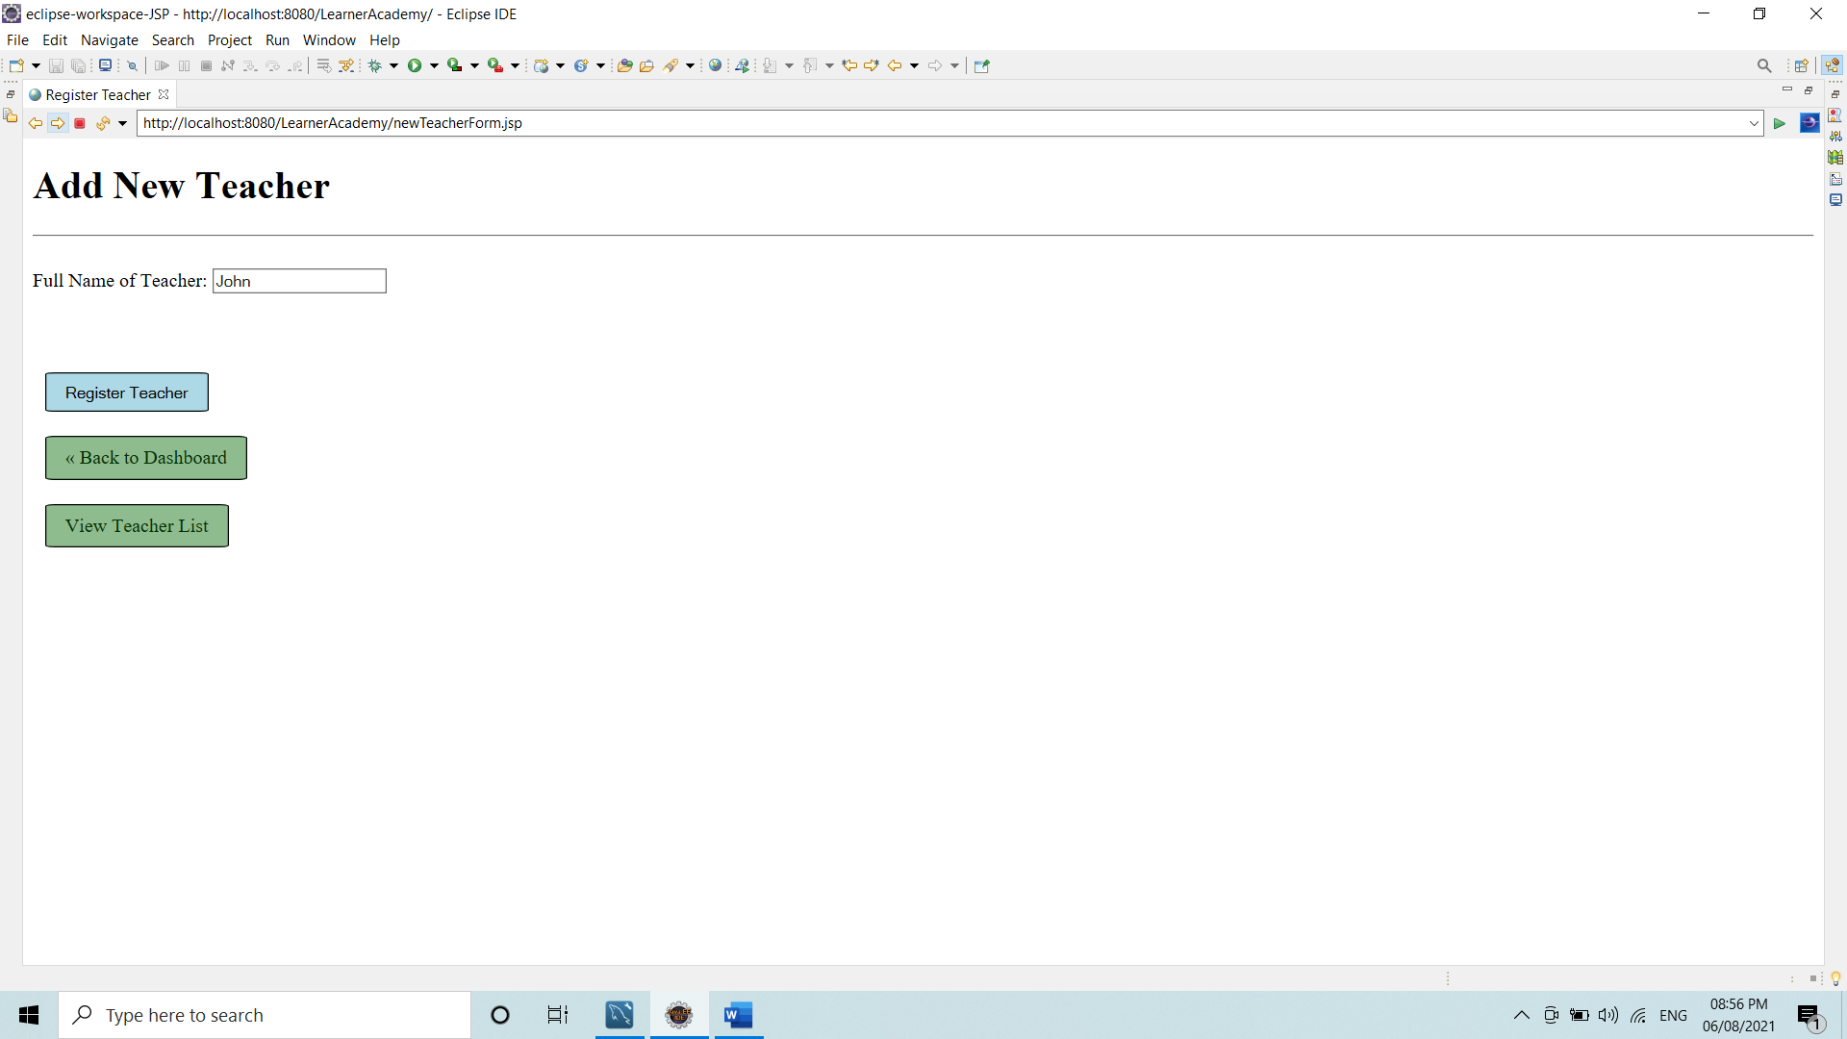

It only take name of teacher as parameter.

By clicking on register Teacher, it registers the Teacher.

After Clicking on View Teacher List:

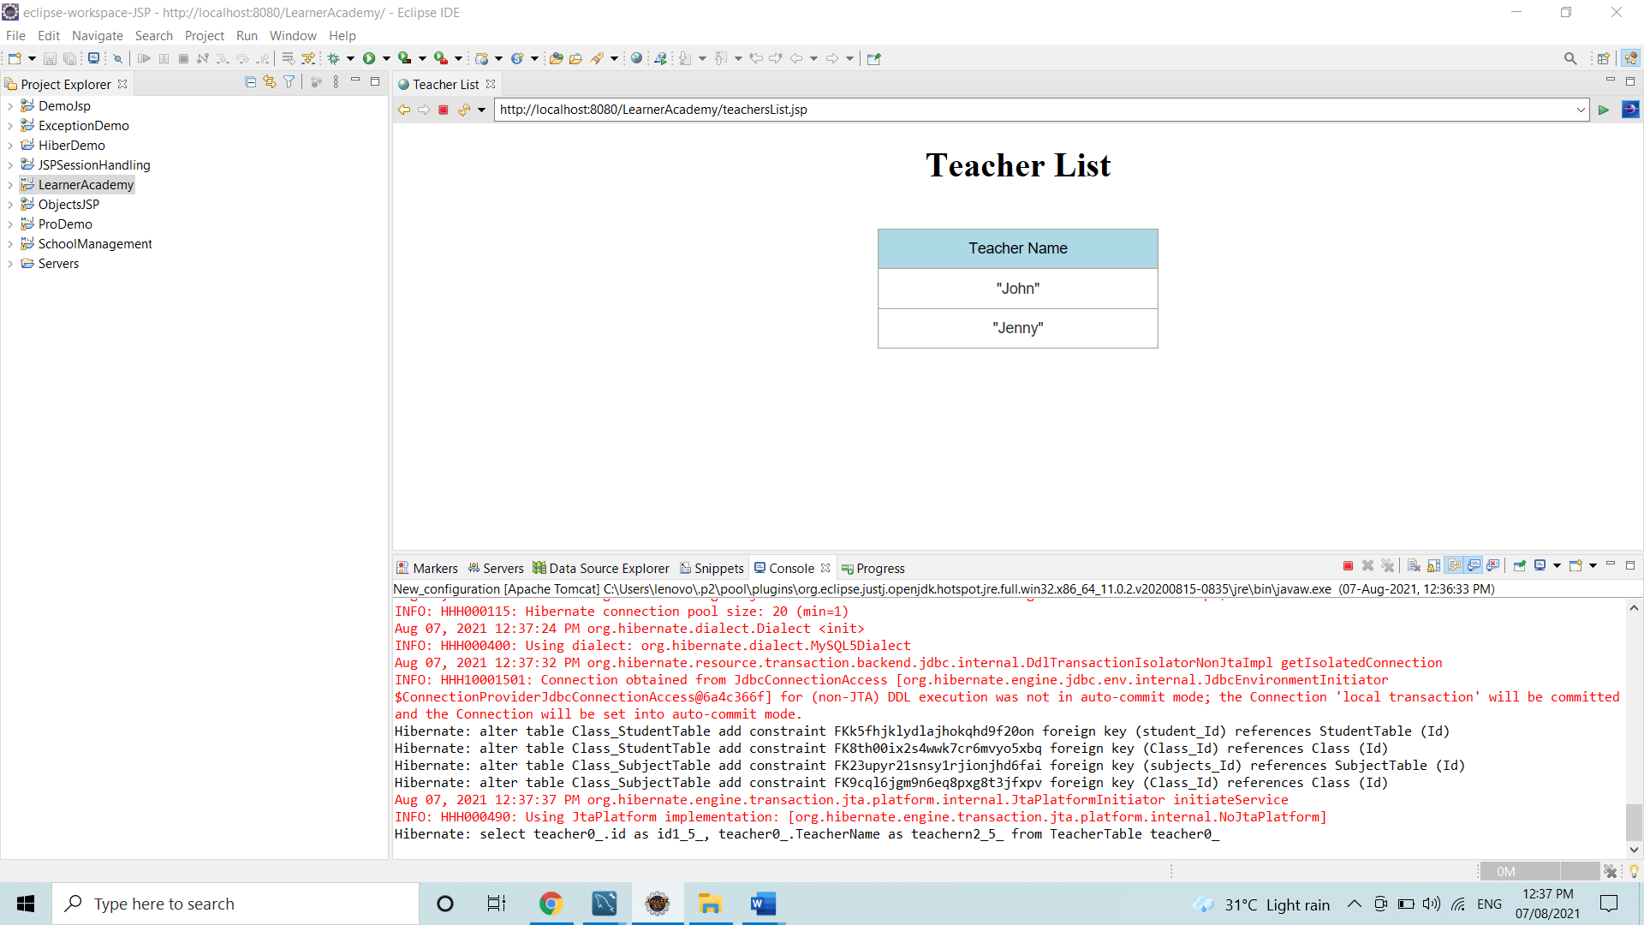

If an error occurs:

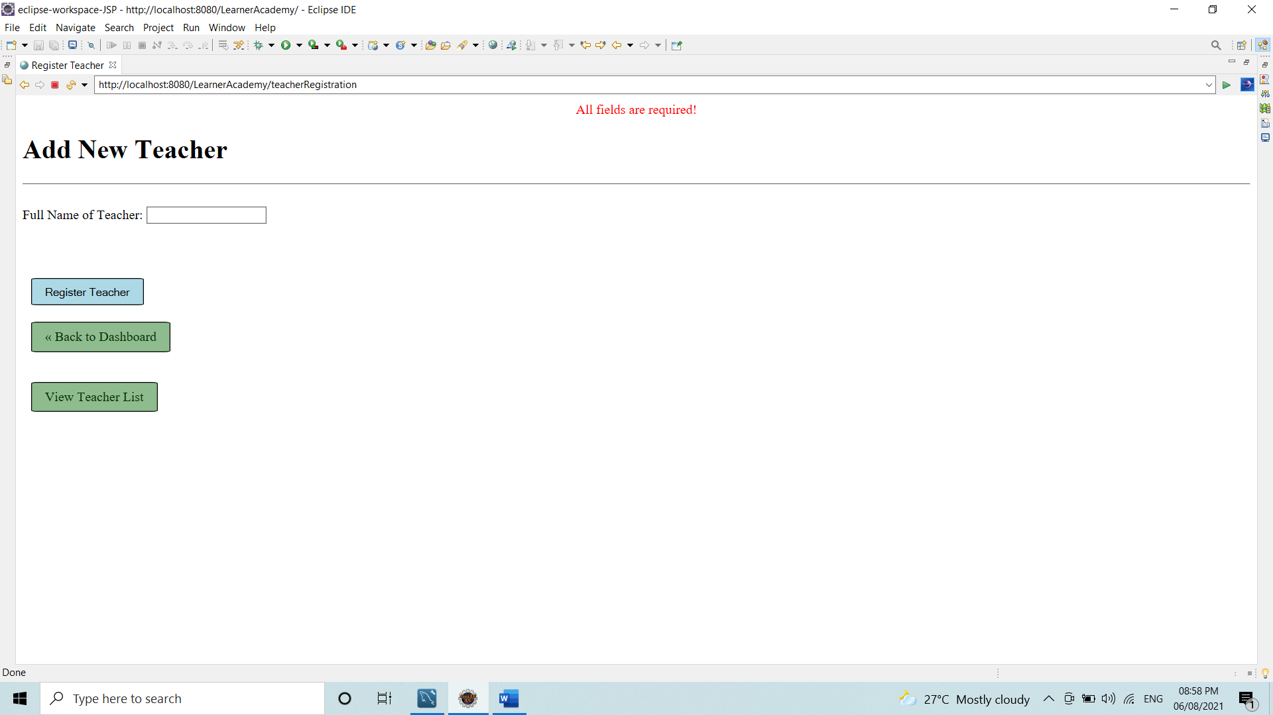

After Selecting Add New Subject

It takes 3 Parameters:

* Subject Name
* Class to which Subject is to mapped
* Teacher who will teach the subject.

There is drop down list for Class and Teacher from which you could select the present teacher and class for the subject.

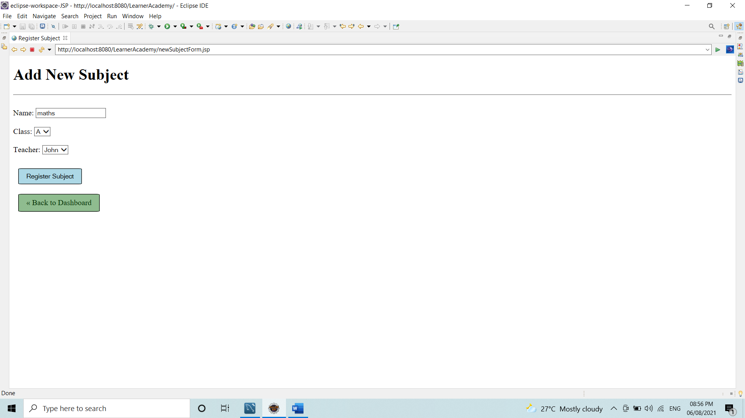

If any error occurs:

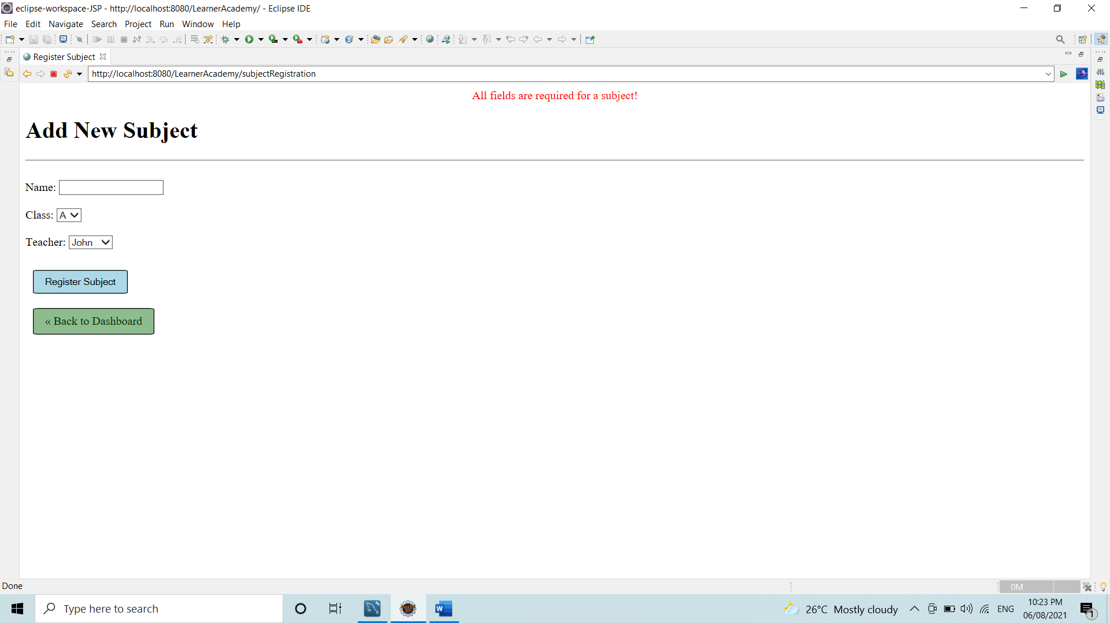

After Selecting Add New Student

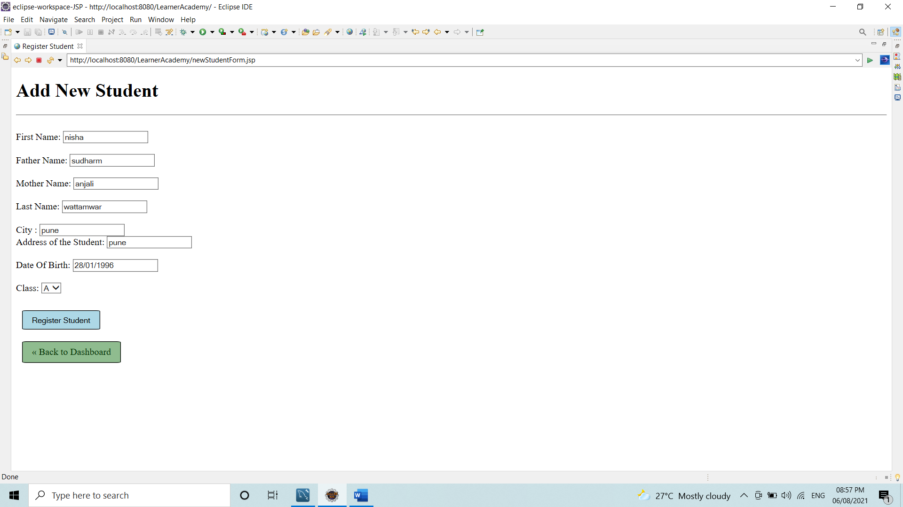

**Note:** The Date of birth format must be DD-MMM-YYYY.

If an error occurs:

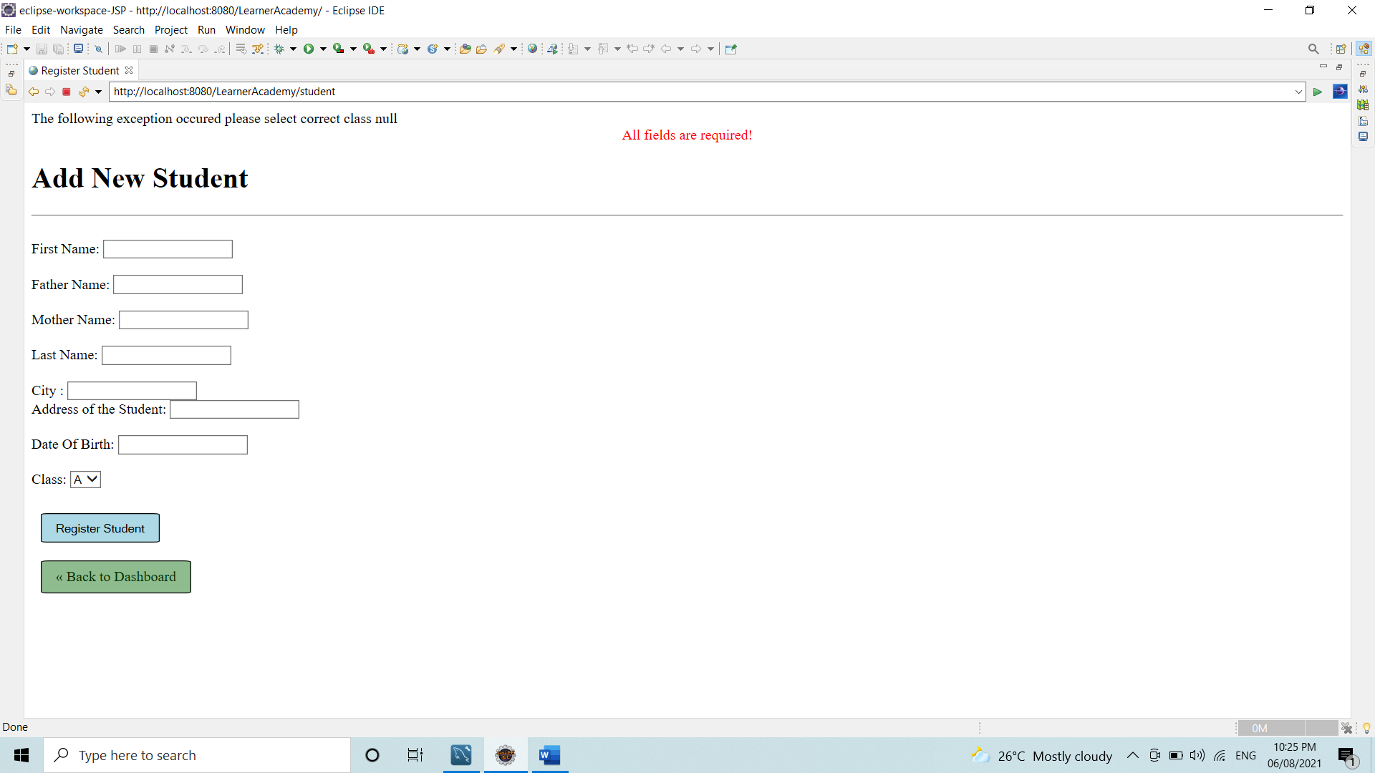

After selecting View Student List

